4. Train Reservation System
Aim:
To develop an online train reservation system for searching trains, checking seats and reserving tickets.
Algorithm:
- Start the railway reservation system.
- Login using valid credentials.
- Enter source, destination, date and class.
- Display available trains and seats.
- Select train and enter passenger details.
- Make payment and generate ticket/PNR.
- Allow PNR checking and ticket cancellation.
- Stop.
Output:
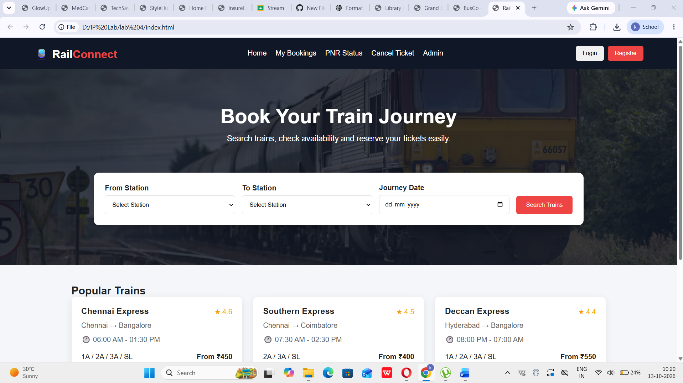
Result:
Thus, the Train Reservation System was successfully developed for online train searching, reservation, PNR checking and cancellation. INTERNET PROGRAMMING LAB EXPERI…

